MAGIC WORDS

MAY IS JEWISH AMERICAN HERITAGE MONTH:
A NEW NOVEL TELLS A FACT-BASED STORY OF A JEW WHO FOUGHT
FOR AMERICAN INDIANS AND A MAGICIAN WHO AMAZED THE WORLD

If you asked most Americans about the relationship between Jewish immigrants and the American Indian they would probably guess that there wasn’t one. But for those few familiar with the life story of one Julius Meyer, the answer would be very different.
Julius immigrated to the United States in 1867 to join his brother in Omaha, Nebraska. He soon became fascinated with American Indian life and culture and became one of the West’s most respected Indian agents and traders. He spoke seven native languages and was the interpreter for many of the most famous Indian chiefs of the 19th century, including Sitting Bull, Spotted Tail, Red Cloud, Iron Bull, Swift Bear and Pawnee Killer.
In his new novel Magic Words, Gerald Kolpan, author of Etta, tells Julius’s exciting story – his capture by the Ponca; his romance with the daughter of a great chief and his progress from slave to the status of Box-ka-re-sha-hash-te-ka: “curly-headed chief with one tongue.” Along the way, Julius encounters a wild and colorful cast of characters: the mysterious Prophet John McGarrigle, clairvoyant Indian scout; Lady-Jane Little Feather, a glamorous - and murderous - prostitute destined to become the scandal of two continents; Standing Bear; the Ponca chief who will bring the United States to court to prove he is a human being; and most important of all, his older cousin Alexander, who will rise from humble apprentice to his vain and devious brother to become the Great Herrmann, the most famous magician in the world.
Magic Words moves from the streets of Philadelphia to the plains of Nebraska; from the glittering stages of Victorian London to the alleys of Brooklyn. Based on historic people and events, the novel tells the tale of one young immigrant’s fight for his own freedom and, in the midst of genocide, the liberation of his adopted people.

Gerald Kolpan, author of Etta: A Novel, was a contributor to NPR’s All Things Considered and an Emmy award-winning television reporter. He lives in Philadelphia.

For more information, please contact Maia Larson at: maia@pegasusbooks.us
$25.95 • 416 pages • Hardcover • 978-1-60598-369-1 • Fiction

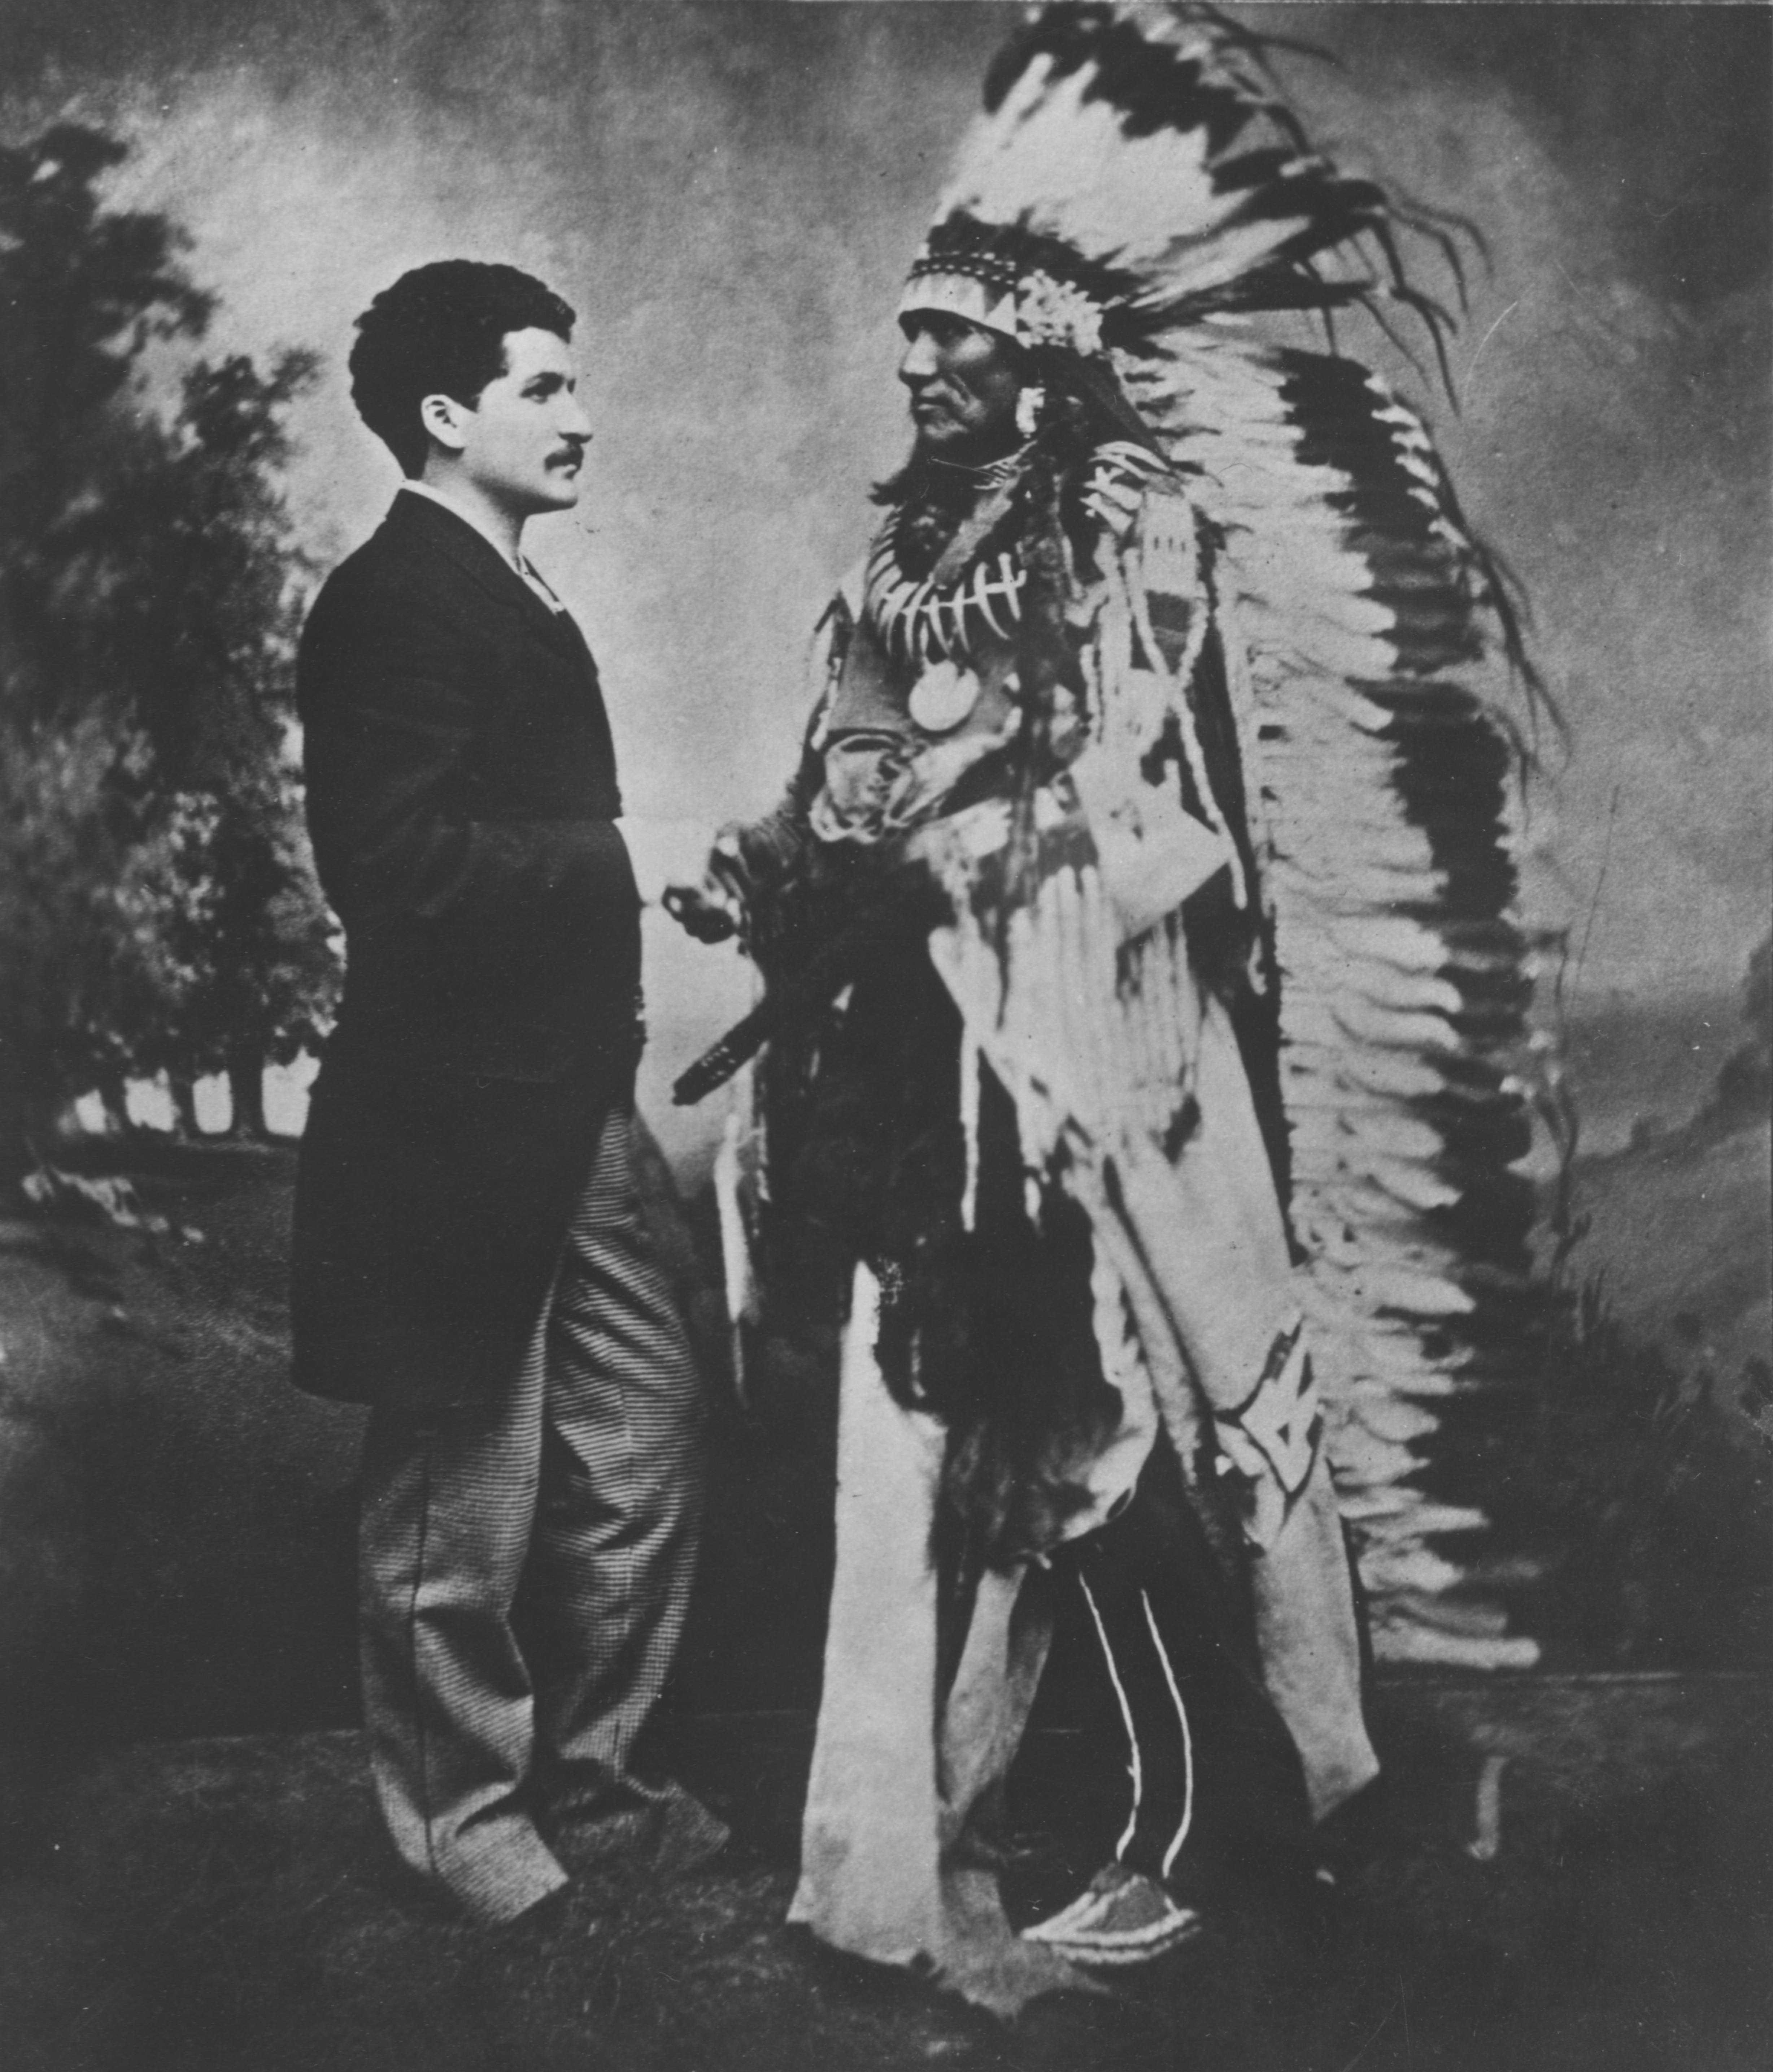

Julius Meyer with Chief Standing Bear. Credit: Douglas County, Nebraska Historical Society.

MAGIC WORDS

MAY IS JEWISH AMERICAN HERITAGE MONTH:
A NEW NOVEL TELLS THE STORY OF A LONG-FORGOTTEN JEWISH MAGICIAN,
ONCE THE MOST FAMOUS CONJURER ON EARTH

He astounded audiences throughout the world. He sold out the Egyptian Theatre in London for one thousand straight nights - a record that still stands. He was a Jewish-American who introduced many of the famous stage illusions that magicians still use to thrill audiences today. He was of course, Harry Houdini. Right? Wrong.

Alexander Herrmann (1844-1896) was the most famous magician in the world 20 years before Houdini. As the Great Herrmann, he introduced such amazing illusions as The Cake From A Hat, The Floating Boy and the infamous Bullet Catch. His devilish mustache and pointed beard is still the image many see when they think of a stage wizard.

Now, Gerald Kolpan’s new novel Magic Words brings this amazing historical figure back to life. In the book, Alexander accompanies his younger cousin, Julius Meyer, to America. Serving as the lowly apprentice to his vain and imperious brother, Compars, Alex struggles to create a never-before-attempted illusion that will bring him fame and glory beyond what any magician has known. During a fateful performance for Julius’s Ponca Indian friends, Alex encounters the glamorous – and murderous - Lady-Jane, a former prostitute who Alex transforms into history’s first female magician’s assistant and who will become the most scandalous woman on two continents.

Part historical epic, part murder mystery, Magic Words restores to the imagination a dashing and romantic figure who changed the face of magic forever.

Gerald Kolpan, author of Etta: A Novel, was a contributor to NPR’s All Things Considered and an Emmy award-winning television reporter. He lives in Philadelphia. Magic Words is his second book.

For more information, please contact Maia Larson at: maia@pegasusbooks.us

$25.95 • 416 pages • Hardcover • 978-1-60598-369-1 • Fiction

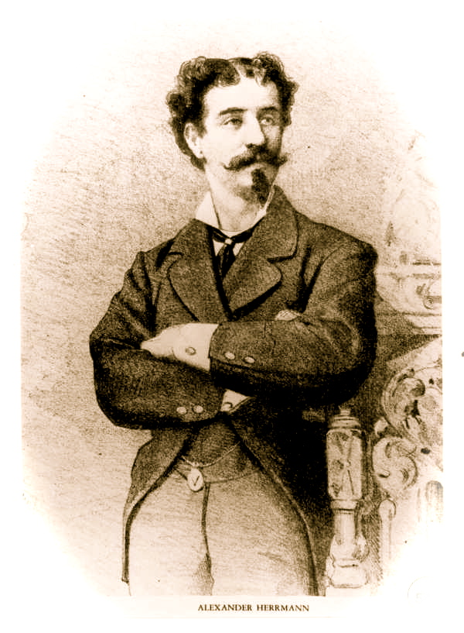
Alexander Herrmann early in his career.

ABOUT THE AUTHOR

Gerald Kolpan was born in New York City and grew up in New Rochelle, Westchester County, NY.

He came to Philadelphia to attend The Philadelphia College of Art (now The University of the Arts) where he received his Bachelor of Fine Arts degree. After college, Gerald launched several successful careers. He was an illustrator for books, magazines and advertising for over a decade and later became an advertising copywriter and art director. At the dawn of the punk era, he even fronted a rock band.

When the advertising business began to bore him, Gerald set his sights on a writing career. Beginning as a freelancer, he wrote articles for newspapers nationwide. Some of his clients have included the Los Angeles Times, the Milwaukee Journal, the Miami Herald and both the Philadelphia Inquirer and Daily News. He also wrote the column "Fulminations" for City Paper, Philadelphia's leading alternative weekly.

In 1979, Gerald launched his media career. Beginning as a volunteer at the University of Pennsylvania's radio station, he eventually gained national notice as a contributor to National Public Radio's news program All Things Considered. His witty commentaries and unique feature reports were favorite "kickers," often closing the nightly broadcast. He was also a contributor to the WNYC radio series Future Forward.

On the strength of his writing, in 1987 WTXF television hired Gerald to be its features reporter. He remained at the station for the next twenty years. In addition to his stories for the 11am, 5pm, 6pm and 10pm shows, his work was often seen nationally and internationally on the Fox News Channel and CNN.

Gerald has earned numerous honors for his work, including 8 Middle Atlantic Emmy awards in such categories as best feature story, best feature series, best medical and science reporting and best television news writer. He has won Philadelphia Magazine's "Best of Philly" award and was chosen as a member of the Philadelphia Daily News TV Dream Team. He has also won awards from the Radio and Television News Directors Association and the Associated Press.

In March 2009, Ballantine Books published his first novel, Etta, a fictionalized account of the life of Etta Place, purported girlfriend of the Sundance Kid. The book received stellar reviews from Kirkus, Library Journal; Publishers Weekly; the Denver Post; the San Francisco Chronicle; the Chicago Sun-Times; the Philadelphia Inquirer; the Philadelphia City Paper; OK! Magazine; Booklist; and the Newark Star Ledger among others. The American Library Association named Etta one of the seven best works of historical fiction of 2009. Currently, it maintains a four-star rating on Amazon.

In November, 2010, Gerald became a part of Akashic Books’ phenomenally successful “Noir” series, with the publication of the anthology, Philadelphia Noir. Gerald’s contribution is The Ratcatcher: the story of a Philly low-life and his introduction to show business. Typically for Gerald, the story is set at the turn of the last century.

Pegasus Books published his second novel, Magic Words in 2012.

Gerald Kolpan lives in Philadelphia with his wife, Joan Weiner. Their daughter, Kate is in graduate school and their son, Ned is a fledgling screenwriter.

Gerald Kolpan author photo. Credit: Jonathan Rubin/Studio Nine

Author website:
www.geraldkolpan.com

VIDEOS for the book:

Book Trailer:

Author Interview:

American Jews and American Indians: Blazing Saddles It Wasn’t.
By Gerald Kolpan

When a modern audience thinks of American Indians and American Jews, the image that comes to mind is likely to be that of Mel Brooks as an Indian chief in Blazing Saddles.

Dressed in ornate plains schmattes (including war bonnet), and astride a paint pony, Brooks and his warriors come upon a prairie schooner carrying an African-American family. “Chief” Brooks looks at the little group as they huddle together in terror, and then turns to his closest companion who is raising his tomahawk to strike:

No, no, zayt nisht meshuge! Loz im geyn! Abi gezint! Take off! Hosti gezen in dayne lebn? (Don’t be crazy! Let him go. As long as you’re healthy! Take off! Have you ever seen such a thing?).

The “chief” lets the family go in peace, quickly stating the reason for his mercy:

“They darker than us!”

It’s either funny or offensive or a little of both depending upon who’s watching; but for many, it’s the only reference to Jews and Indians they are ever likely to see.

Pity - because there was a bone fide Jewish Indian chief. His is a tale of guts and brains, as are most stories about Jews among the Indians.

Almost from the beginning of Westward expansion, Jews have made a home on the range. They were fur trappers, gold miners, cowboys, peddlers and scouts. There were sheriffs, marshals, mayors of small towns and at least one gunfighter. A shana medele from San Francisco married Wyatt Earp; a storekeeper from Bavaria and a tailor from Latvia invented blue jeans. Jews frequented the saloons, dance halls and bordellos. And they traded, fought with and yes, even married their Native neighbors.

Most of the Jews headed west for the same reasons that they had come to America in the first place; they were seeking freedom from the discrimination that had long been their lot in Europe. But even in the Golden Land, large cities like New York, Philadelphia and Boston had strict social codes that excluded many ethnic groups. Jews and others found that most of the professions were closed to them; and religious and political elites excluded them from their clubs and social organizations.

No one could do that on the plains of Nebraska or in the mountains of Colorado.

Czechoslovakian émigré Sigmund Schlesinger was one such pioneer. After losing his job in Philadelphia to a returning Civil War soldier, Schlesinger went to eastern Kansas where he found work on the railroad, only to be laid off again when hostile Sioux took charge of the tracks. Needing work, he volunteered to be an Indian Scout for the Army, despite never having ridden a horse or shot a gun. A quick study, he became a hero of the Battle of Breecher’s Island, Colorado, said by some historians to be the most ferocious in the history of the Indian Wars. "We did not know what tribe or what chiefs we were fighting," Schlesinger said at the time, but as Jerry Klinger writes in the Jewish Magazine, the young man’s valor did not go unrecorded. Years after the battle, his commanding officer wrote to Rabbi Henry Cohen of Galveston, Texas:

He had never been in action prior to our fight with the Indians and throughout the whole engagement which was one of the hardest, if not the very hardest, ever fought on the Western plains, he behaved with great courage, cool persistence and a dogged determination that won my unstinted admiration as well as that of his comrades, many of whom had seen service throughout the War of Rebellion on one side or the other.

I can accord him no higher praise than that he was the equal of many in courage, steady and persistent devotion to duty, and unswerving and tenacious pluck of any man in my command.

But not all Jews encountered the Indians in battle. Some were among their closest friends – and became trusted advocates for their rights and freedoms.

Such a man was Julius Meyer, born in Bromberg, Prussia (now Poland) in 1851.

Meyer came to the United States in 1866 at age 13. In Europe, he had been a yeshiver bocher and a talented musician. Shortly after his arrival, he joined his older brothers Max, Adolph and Moritz in Omaha where they had a prospering cigar and jewelry business. Separate from his brothers, Julius began trading with Indian tribes like the Ponca, Omaha, Pawnee and Sioux. So well known did he become for his honesty that the Indians dubbed him “Box-Ka-Re-Sha-Hash-Ta-Ka: “the curly-headed chief who speaks with one tongue.” Julius was fascinated by Native culture and lived with various tribes for long periods. He eventually learned the language of his new friends and he may have spoken as many as seven different Indian dialects.

According to Julius, in 1869, he was attacked by a hostile tribe. They tried to kill him – and it was only the intercession of Standing Bear, chief of the Ponca, which saved his life. Thus began a friendship that lasted until Meyer’s death in 1909. Julius became Standing Bear’s interpreter and soon was translating for such famous chiefs as Sitting Bull, Red Cloud, Spotted Tail and Swift Bear. Many photographs survive of the small curly-haired man dressed in full Indian garb and surrounded by these great warriors.

According to an article in the American Hebrew dated September 10, 1926, Lena Rehfeld, Julius’s niece, was present when her uncle had some Indian dignitaries to dinner. “We children gazed upon their fierce-looking visages in awe and trembling,” Miss Rehfeld recalled. “They sat far away from table and were innocent of the use of forks and knives.”

For many years, Meyer served as Omaha’s government Indian agent, often fighting for Native rights against a state and nation that were constantly trying to reduce Indian territories. Julius was also known as a man who knew how to make a dollar for his friends (and himself). One such scheme involved taking Standing Bear and a group of the Ponca on a yearlong jaunt to the 1889 Paris Exposition where they caused a sensation.

Julius kept up his association with Standing Bear and the Nebraska tribes until May 10, 1909 – the day he was discovered dead in Omaha’s Hanscom Park. He was clutching a revolver and had two bullet holes in him: one in his temple and another in his chest. He was legally declared a suicide, although to this day, there are people who believe that this great Jewish friend of the Indian was murdered.

Still, if Julius Meyer was an honorary Indian, Solomon Bibo became the real thing: real enough, in fact, to become a chief.

Bibo was born in Westphalia in what is now Germany, in 1853. Like Meyer, he immigrated in 1869 and joined his brothers in business. The Bibos were among Santa Fe, New Mexico’s most successful traders, known for square dealing with their Indian neighbors. Like many Jewish peddlers and tradesmen, they were welcome in the Indian villages. Bibo and his brothers became speakers of several Indian dialects and Solomon was often called upon by the Acoma Pueblo to negotiate treaties between their tribe and the U.S. government.

In 1885, Bibo married Juana Valle, the granddaughter of a former Acoma chief, not once, but twice: on May 1, they were united in an Indian Ceremony and then again on August 30 by a local Justice of the Peace.

Later that year, the Acomas elected Bibo their new “governor,” the equivalent of tribal chief - a position he held four times. He helped create the tribe’s first modern education system, hired its first schoolteacher and supervised the first Acoma school building.

Solomon and Juana were married for nearly fifty years and had six children. Years before, she had converted to Judaism. At 13, their son, Leroy became a traditional Bar Mitzvah but also participated in the Acoma rituals of manhood. The couple was separated only by his death on May 4, 1934; they are buried in a Jewish Cemetery in Colma, California.

Gerald Kolpan is a former television reporter. His first novel, Etta, a fictionalized account of the female outlaw Etta Place, was published IN 2009 by Ballantine. He lives in Philadelphia. His new novel, Magic Words, which features Julius Meyer, will be published by Pegasus in May, 2012.

